
User's Manual

3G Camera

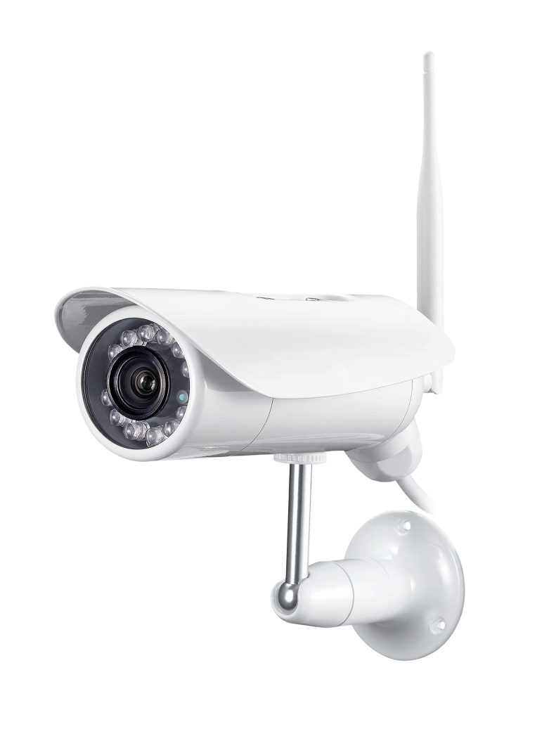

Please read this manual carefully before you attempt to
install this product and retain it for your future reference.
Contents

Main Features……………………………………………………………………………5
INSTALLATION 6
Setting up the Network Camera over the Internet 9
Operating Bar 16
Viewing the camera from your mobile devices 18
Network Camera Setting Interface 20
Camera 23
Camera Setup 24
Stream Setup 24
OSD Setup 26
Night Vision Setup (IR IPCAM) 27
Network 28
3G Setup 29
TCP/IP Setup 30
DDNS Setup 31
UPNP Setup 32
P2P Setup……………………………………………………………………………………… 32
Storage 34
Storage Setup 35
Browse Storage 36
Format SD Card 36
Task 37
Motion Detection 37
Digital I/O Setup 39
Schedule Setup 40
Task Management 40
Email alarm sending 41
Email periodic sending 42
FTP alarm sending 43
FTP periodic sending 44
HTTP alarm sending 45
HTTP periodic sending 46
Snapshot to storage on alarm 47
Snapshot to storage periodically 48
Record to storage on alarm 48
Record to storage continuously 49
Sending files in storage to FTP server 49
IOS push notification…………………………………………………………………………..50
Tools 51
System Identity 52
User Management 53
Date & Time 54
Backup or Reset 54
Automatic reboot setup...................................................................................................................54
Firmware Upgrade ………………………………………………………………………………56
SPEEDREAD YOUR NETWORK CAMERA 57
Wizard 58
System 58
Support 58
Reboot 59
ADVANCED SETTINGS 59
DEFAULT SETTINGS 62
SPECIFICATIONS 67
Frequently Asked Questions 71
GLOSSARY OF TERMS 75
World APN 75

INTRODUCTION
Thank you for your interest and support in our product and purchasing this wireless network camera. The camera can be accessed remotely, and controlled from any PC/laptop over the Intranet or Internet via web browser. The user-friendly installation procedure and intuitive web-based interface offer easy integration with your LAN environment or WiFi system. The camera also comes with a lot of useful alarm tool for notice user any situation. We feel confident that you will be pleased with the quality and features of this product. #
Notice
This product may cause interferences with other wireless equipment that operates at 2.4GHz ISM band. Please turn off one of the equipments to eliminate the interference.

Product Assurance
This camera will emit electromagnetic wave, just like other wireless products, but its transmitting power is less than other wireless products such as mobile phones. The 2.4GHz wireless camera meets wireless frequency security standards and recommended indexes while working. These standards and indexes are certificated by academic organization and represent the cogitative research of the scientific workers who continuously explore and annotate the involved fields. So we believe that our products are safe for customers.

Approval Information
All our products meet the requirements of approval FCC or CE, and are granted the FCC or CE certification. They are authorized to bear FCC or CE mark.
FCC
This equipment has been tested and found to comply with the limits for a Class B digital device, pursuant to Part 15 of the FCC rules. These limits are designed to provide reasonable protection against harmful interference in a residential installation. This equipment generates, uses and can radiate radio frequency energy and, if not installed and used in accordance with the instructions, may cause harmful interference to radio communications. However, there is no guarantee that interference will not occur in a particular installation. If this equipment does cause harmful interference to radio or television reception, which can be determined by turning the equipment off and on, the user is encouraged to try to correct the interference by one or more of the following measures: -Reorient or relocate the receiving antenna. -Increase the separation between the equipment and the receiver. -Connect the equipment into an outlet on a circuit different from that to which the receiver is connected. -Consult the dealer or an experienced radio/TV technician for help.
This device complies with Part 15 of the FCC Rules. Operation is subject to the following two conditions:
- (1) This device may not cause harmful interference, and
- (2) this device must accept any interference received, including interference that may cause undesired operation Changes and modification not expressly approved by the manufacturer or registrant of this equipment can void your authority to operate this equipment under Federal Communications Commissions rules.

CE
This product complies with standards including Low Voltage Device Directive 73/23/EEC; EMC Directive 89/336/EEC and R&TTE Directive 1999/5/EC. It passed the subject tests by the authority concerned and is authorized to bear CE mark.

Restrictions
1. DO NOT use this product to violate one's privacy. Monitoring one's activities without consent is illegal and this product is not designed and manufactured for such purpose.
2. DO NOT put this product near any medical equipment. Radio waves might potentially cause breakdown of electrical medical equipment.
3. This product should be placed at least 1 foot away from any heart pacemaker. Radio waves might potentially influence heart pacemaker.
4. DO NOT use this product for any illegal activities. It is the user’s responsibility to ensure that the usage of this camera is of a legal nature.

Maintenance
1. Ensure that the camera and its power source have sufficient ventilation;
2. Do not shake, strike or drop the product;
3. Keep the camera dry and dustless and avoid exposing it to direct sunlight;
4. Do not place the product near any magnetic objects;
5. Avoid putting the product in places where there is constant temperature and humidity change;
6. Keep the product away from heat sources;
7. Do not use the camera near aggressive chemicals;
8. Do not use this camera near water;
9. Do not use the camera in the places which are enclosed by metal. The surrounding metal may shield the electromagnetic waves, and result in failure of signal reception;
10. Please obey the local government's environment protection policy;
11. Please turn off the power when left unused;
12. Do not disassemble or attempt to repair the camera; doing so might cause damage to the product.

MAIN FEATURES

Easy Installation
The camera comes with built-in 3G（WCDMA） capability and a Web Server, therefore there is no need to install a driver. The setup CD-ROM includes the Camera Setup software, User Manual and Quick Installation Guide.
With industry standard automatic configuration-UPnP(Universal Plug and Play), your PC will discover and connect to your camera automatically. Once connected, using a simple Web browser you can see what the camera sees from anywhere in the world!
The camera can be either wall-mounted or ceiling-mounted using the supplied stand. It can also be placed on a desktop using the supplied stand, thus providing a flexible installation solution.

Simultaneous High-Speed H.264, MPEG-4 and Motion JPEG
The camera allows live the H.264, MPEG-4 and Motion JPEG streams simultaneously. The camera features H.264/MPEG4 compression which compresses the video to make transmission faster and more efficient. The H.264/MPEG4 and MJPEG image can be transmitted at 30 frames per second.
Simultaneous HTTP and RTSP streaming
The camera support HTTP and RTSP/RTP/RTCP protocol, and provide multiple HTTP and RTSP streams simultaneously.
Audio Transmission
The camera comes with a built-in microphone for audio monitoring as well as video monitoring. Sound captured by the camera is transmitted to the client’s PC.

3G card slot
Fluently view the camera via 3G network. Perfect for viewing on farm area, mine field and pasture.

Snapshot and Recording
You can capture a still image of the camera view on your PC and save the image as JPG or BMP format file. You also can record the video and audio captured by the camera on your PC and save as an ASF format file.
Motion Detection Function
The camera can detect changes in the image being monitored. Once a change occurs it will send an email to up to 3 email addresses with a video file or snapshot attached. The video file or snapshot can also be uploaded to an FTP server. In addition the camera can be configured to send images at regular intervals.
OSD Function
OSD (On Screen Display) function can display system name, date and time, and user-defined on screen.
Authentication
An authentication window requires you to enter the user ID and password. Password security can prevent unregistered users from accessing your camera. Users can select Basic Authentication method or Digest Access Authentication method.
Multi-Client Access
The camera allows up to 16 users to view the video simultaneously. Please note that it is possible that as the number of simultaneously connected users to camera increases, the overall motion performance will decrease.
Infrared Night Vision
The camera utilizes 15 infrared LED to provide high light in darks environment. When the environment is
dark, the LED will be opened automatically due to a photosensitive component, and the moving images will be changed to Black and White. Users can monitor clearly the things within 15 meters distance. Users also
can select open or close the infrared LED manually, and select whether change the images to black and white or color automatically.

Adapter
This product conforms with the authenticated AC adapter. The adapter is marked with one or more of the following:



Note: When using the power adapter, make sure the rating voltage on it is compatible with that of the device to avoid potential damages resulting from incorrect usage of power supply.

PC System Requirements
The PC (Personal Computer) and the network must meet the following technical specifications for camera to work properly.
1. Processor: Intel Pentium III, 1GHz or Higher (Pentium IV, 2 GHz or Higher recommended)
2. RAM: 256 MB or more
3. Color Monitor: Suggest at least 800x600 and the latest driver for the Display Adapter
4. OS(Operating System): Windows 2000/XP/Vista
5. Web Browser: Internet Explorer Version 5.0 or above, DirectX 9.0c or later
6. Network Protocol: TCP/IP network protocol installed
7. Interface: 10/100 Mbps Ethernet® card/Wireless Network card for your network
connection
8. Other: CD-ROM Drive

INSTALLATION

Setting up the Network Camera over the Internet

This section explains how to configure the Network Camera to an Internet connection.
1. If you have external devices such as sensors and alarms, make the connection from the general I/O terminal block.
2. Use the supplied RJ45 female/female coupler to connect the Network Camera to a switch.use Category 5 Cross Cable when Network Camera is directly connected to PC.
3. Connect the power cable from the Network Camera to a power outlet.

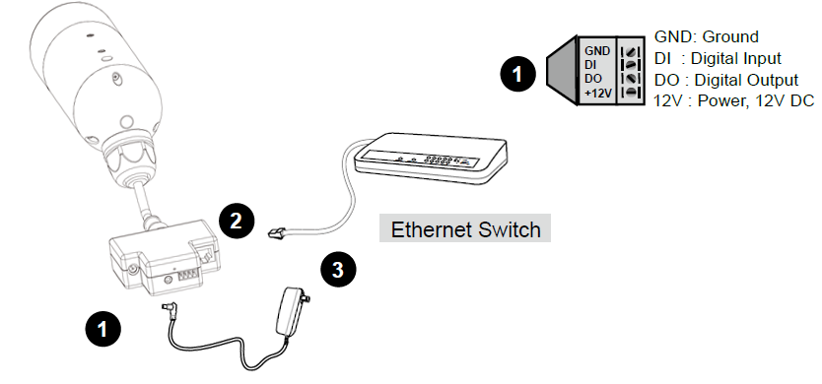

Internet connection via a router

Before setting up the Network Camera over the Internet, make sure you have a router and follow the steps below.
1. Connect your Network Camera behind a router, the Internet environment is illustrated below.
Regarding how to obtain your IP address, please refer to on page 20 for details.

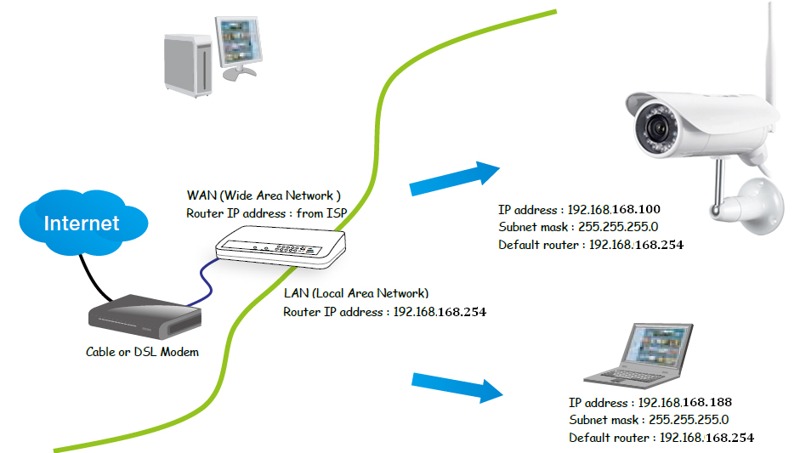

2. In this case, if the Local Area Network (LAN) IP address of your Network Camera is 192.168.168.100, please forward the following ports for the Network Camera on the router.

■ HTTP port
■ RTSP port
■ RTP port for audio
■ RTCP port for audio
■ RTP port for video
■ RTCP port for video

If you have changed the port numbers on the Network page, please open the ports accordingly on your router. For information on how to forward ports on the router, please refer to your router’s user’s manual.

3. Find out the public IP address of your router provided by your ISP (Internet Service Provider). Use the public IP and the secondary HTTP port to access the Network Camera from the Internet. Please refer to Network Type on page 34 for details.

Connecting the camera
Using a standard Ethernet network cable, connect the camera to your network (depending on your own setup, this may be to your router or switch). see figure below

Connect the included power adapter to the power port on the camera and the other end into an electrical socket. see figure below

Check that the power indicator is lit on the front of the camera.

Note:
Please handle the power adapter carefully to avoid the risk of accidental electric shock.

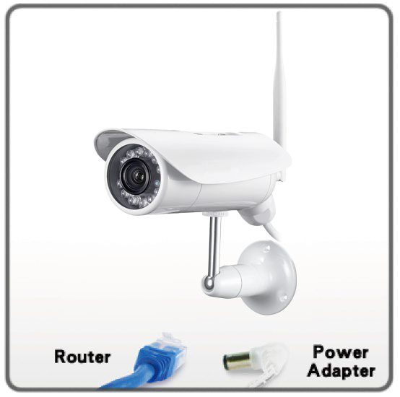

Camera Setup Installation & Usage
The camera Setup utility can easily and quickly detect cameras connected to your local network and list them on the Camera Setup window, also you can use the camera Setup utility to assign an IP address to each camera.
1. Insert the Installation CD into your CD-ROM drive and the installation screen should appear automatically (See image below). If it does not, click “Start” then “Run”. In the text field enter “D:\autorun.exe” (if “D:” is the letter of your CD-ROM Drive)

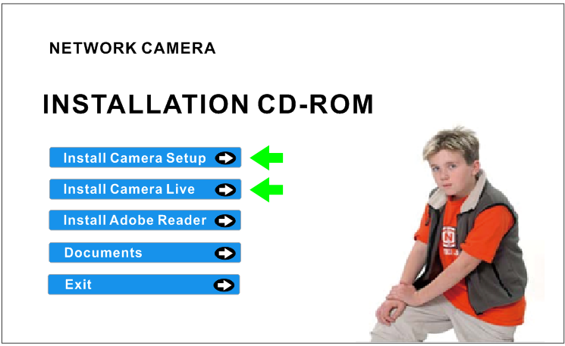

2. Click on “Install Camera Setup” and the following screen will be displayed.

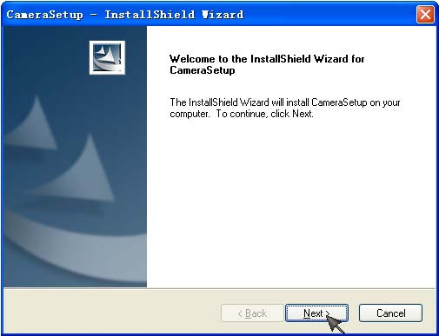

3. If you want to change the default folder click “Change” to replace otherwise click “Next”
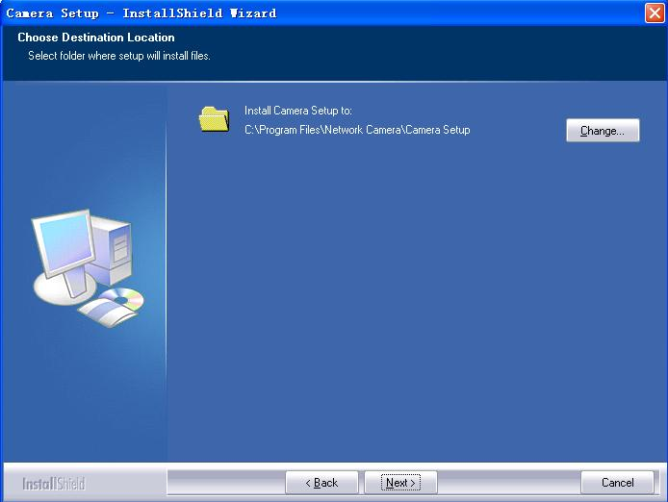

4. Click Install to install Camera Setup.
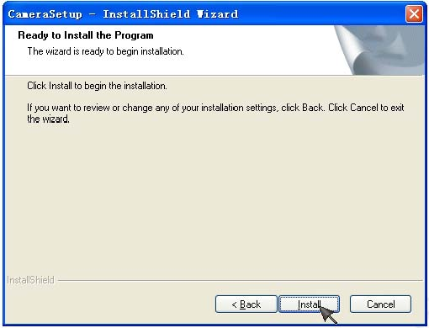

5. Click Finish to end the installation. You should now find a icon 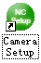on the desktop.
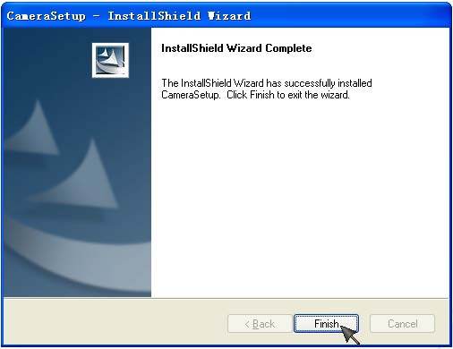
6. Double-click the Camera Setup icon 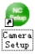 on the Desktop to launch the program. The Camera Setup utility should automatically find your camera if is correctly connected (See image below).
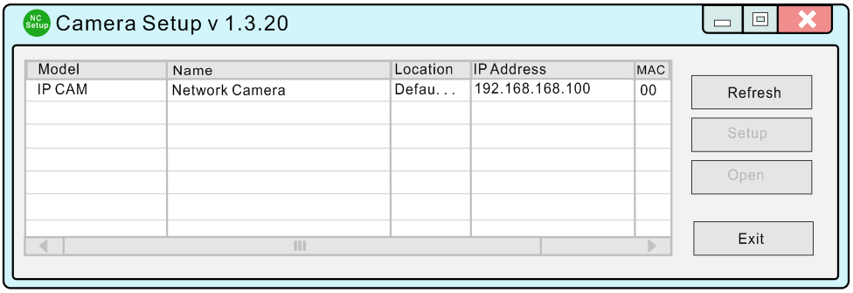
[Refresh] Click Refresh to search for cameras on the local network.
[Setup] Select the required camera and click Setup to configure the network settings for the camera.
[Open] Select the required camera and click Open to access the camera via a web browser.
[Exit] Click Exit to exit the Camera Setup window.
Note: Select and double click one of the cameras from the Device list, to open the camera view via the web browser.

NETWORK CAMERA SCREEN AND SETUP WINDOW
Review Images from the Network Camera
You can select one of the three ways to review pictures from the camera.
1. Input the assigned IP address (or URL) of the camera on the Web Browser. Take 192.168. 168.100 as example. You will see the home page.
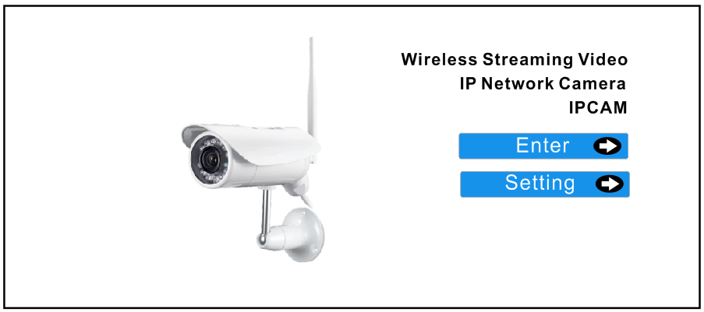
Notes:
Through this welcome page, you could choose to click on the item Enter to access the picture viewing interface or the item Setting to access the system setting interface. The below dialog will appear. Input the correct username (the default is admin, in lowercase) and password (the default is admin, in lowercase). You are allowed to enter the picture viewing interface or the system setting interface.
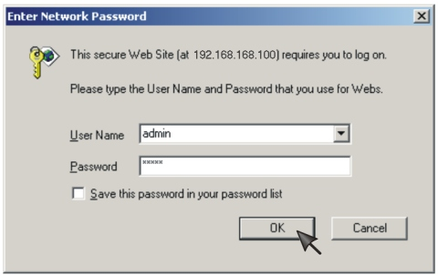
The general users assigned by the administrator are not allowed to enter the system setting interface. They can only be permitted to enter the picture viewing interface.

2. Run the Camera Setup and double-click the relevant camera item.

Operating Bar
Click Enter, you will see the screen.
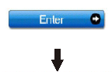
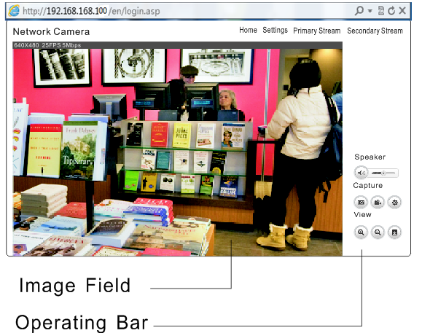

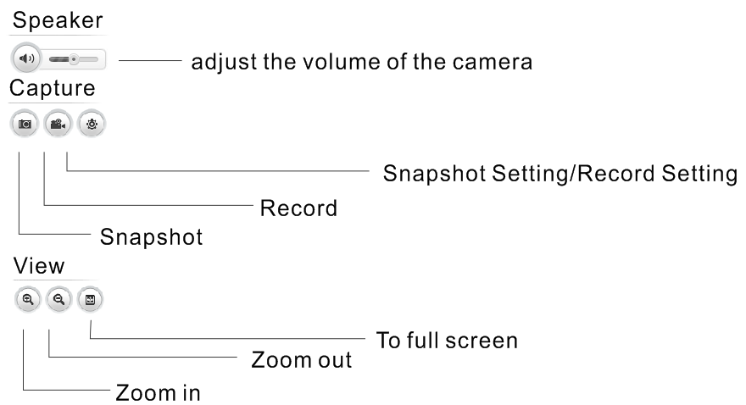

Viewing the camera from your mobile devices.
View in the mobile website browsers.

iOS requires iOS4.3 version or later.
Android OS requires version2.3 or later.
Download APP “Anyscene” in App store or Google play store

View on iPhone, iPad, Android devices.
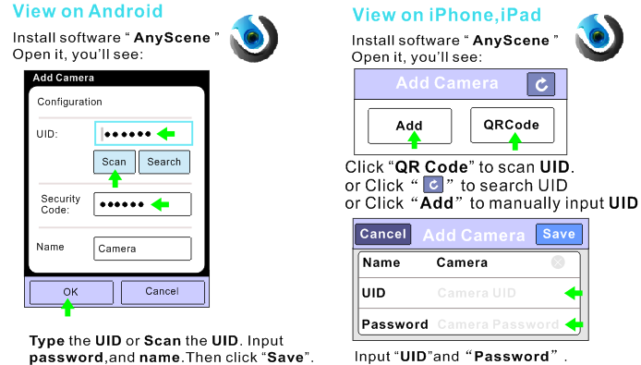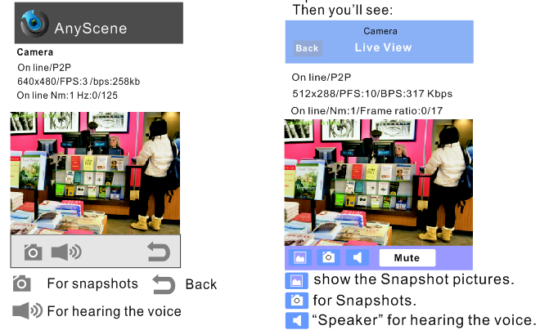
Network Camera Setting Interface

1. Click on settings from the home page. When connecting the camera for the first time or after resetting it to its default settings, the setup interface start page below will load. It is recommend that you change the admin password in order to avoid unauthorized access to the camera. To do this follow the instructions by clicking on the underlined link “here” to access administrator password editing page.

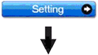
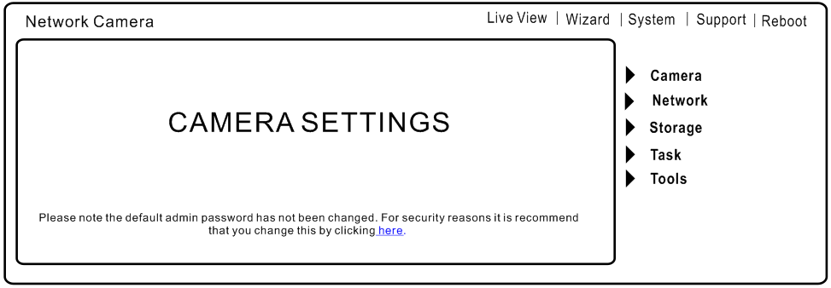
2. Type the password in both fields then click Save. Please take note of the password. If you forget the password, the camera will have to be reset to its default settings in order to gain access to the settings page and this will also reset all other settings you may have changed.

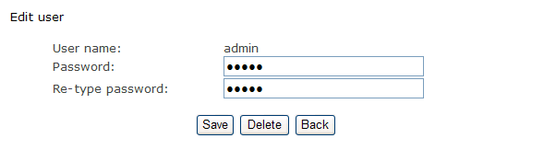

3. You are required to re-login with the changed password.
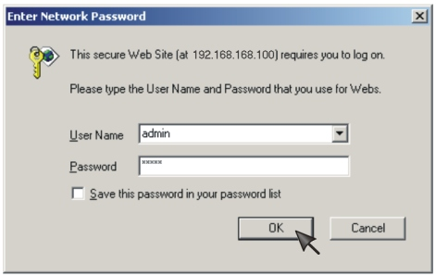
After successful login, the following page will appear.

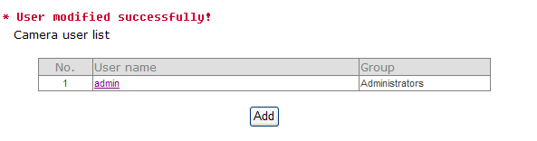

Camera
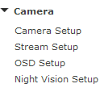

Camera Setup
From the home page click settings and enter the administrator user name and password. Click on Camera Setup under the title Camera to change the image and audio parameters of the camera.
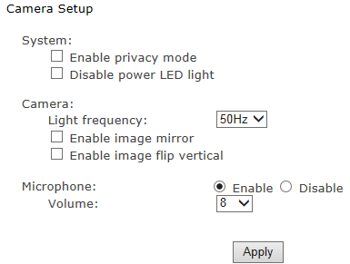
[Enable privacy mode] Videos will not be seen.
[Light frequency] Two options: 50Hz & 60Hz. Set according to the mains frequency in the country of use. For UK this would be 50Hz.
[Microphone] Enable or disable the microphone.
[Speaker] Choose to allow speaker function. And choose the volumn of the speaker.

Click Apply to confirm your settings.

Stream Setup

The camera supports three streams: primary stream, secondary stream and mobile stream.

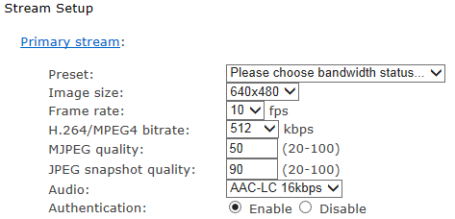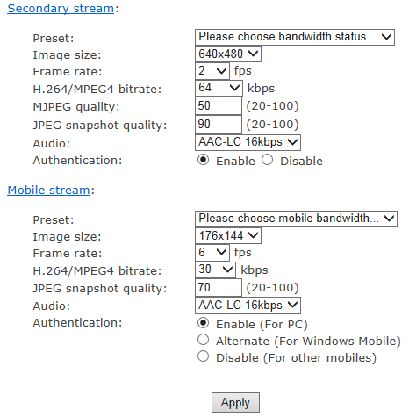
[Image size] Three image resolutions available: 640 x 480(VGA), 320 x 240(QVGA), 160 x 120.
[Frame rate] Twelve options: 1/2/3/4/5/6/8/10/15/20/25/30 frames per second (fps).
[H.264/MPEG4 bit rate] Select H.264/MPEG4 bit rate.Eight options: 64, 128, 256, 512, 768, 1024, 1536, 2048 (kbps).
[JPEG quality] Type MJPEG video quality. (20 – 100), 20 is low quality, 100 is high quality.
[Audio] Enable or disable audio.
[Authentication] Enable or disable.
A stream list page will be shown after clicking the stream name such as “Primary stream”.

[Primary stream] can not be disabled.
A sample of primary stream list as below:
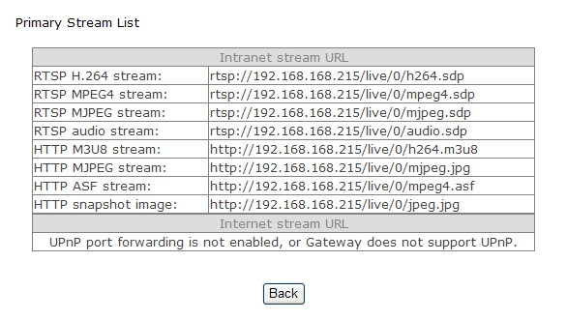
You can use RealPlayer, VLC Player or QuickTime Player to play the live stream from camera in Intranet or Internet.

[Secondary stream] Enable or disable secondary stream.

[Mobile stream] Enable or disable Mobile stream.
You can use mobile phone, Realplayer and QuickTime Player to play the live stream from camera.
The size of video is 176x144.

OSD Setup
This function can display system name, date and time, or use-defined on screen.
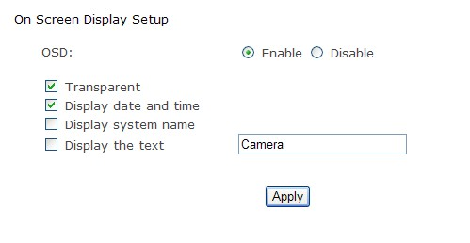

[OSD] Enable or disable OSD function.
[Transparent] Users can select whether change OSD to transparent or not.
[Display date and time] OSD is date and time of camera.
[Display system name] OSD is system name of camera.
[Display the text] OSD is user-defined text.

Click Apply to confirm your settings.

Night Vision Setup
IPCAM have infrared LED, which can be opened automatically when camera check dark environment.

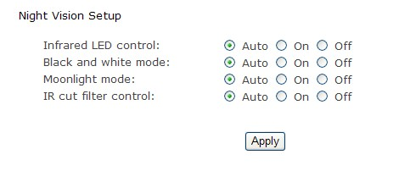
[Infrared LED control] When the environment is dark, the LED will be opened automatically due to a photosensitive component. Users also can select open or close the infrared LED manually.

[Black and white mode] When the environment is dark, the moving images will be changed to Black and White automatically. Users also can select whether change the images to black and white or color manually.

[IR cut filter control] Click to choose Auto, on or off.

Click Apply to confirm your settings.

Network
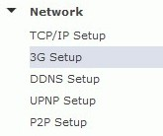

Warning: Using URL to view the camera should cancel the 3G function.
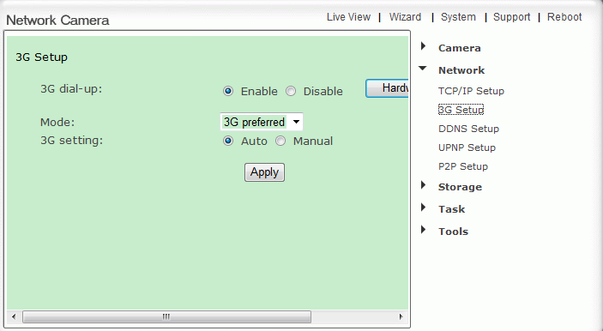

[Enable] Choose Enable or Disable
[Mode] Select 3G preferred
[3G Setting] Choose Auto or Manual

Finally click Apply to confirm your setting.

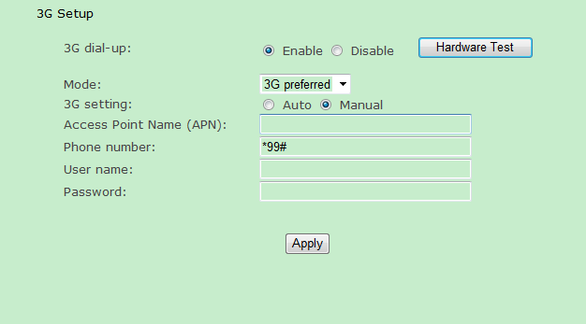
[Enable] Choose Enable or Disable
[Mode] Select 3G preferred
[3G Setting] Choose Manual
[Access point name] Input the access point name.
[Phone number] Input the phone number.
[User Name] Input the User name.
[Password] Input the password.

Finally click Apply to confirm your setting.

TCP/IP Setup
The camera is set up to obtain the IP address automatically (DHCP) by default. Should you may wish to assign the IP address manually, use the TCP/IP Setup page to enter the address details.
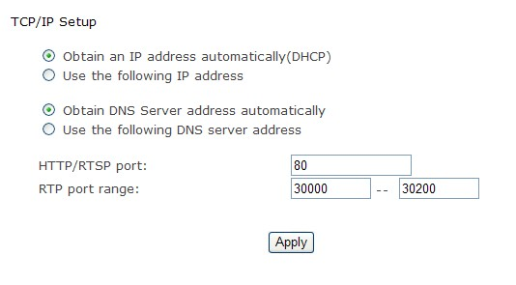
Obtain an IP address automatically(DHCP):
If your network supports a DHCP server (e.g. router) select this option to have the IP address is assigned automatically.
If you select Obtain an IP address automatically you should select Obtain a DNS Server address automatically.

Use the following IP address:
Select this option when a fixed IP is required.
[IP address] Type the IP address of your camera.
[Subnet mask] Type the subnet mask.
[Default gateway] Type the default gateway.

Obtain DNS Server address automatically:
If your network supports a DHCP server (e.g. router) select this option to have the DNS Server address is assigned automatically.

Use the following DNS server address:
[Primary DNS IP address] Type the IP address of the primary DNS server.
[Secondary DNS IP address] Type the IP address of the secondary DNS server, if necessary.

[HTTP/RTSP port]
The default HTTP port number is 80, it is also be used as RTSP port.

[RTP port range] It is for UPnP port forwarding, 1 camera actually use 2 RTP ports, one for video, the other for audio. (See UPnP setup)

[HTTP/RTSP Authentication method] Select Basic Authentication or Digest Access Authentication.

DDNS Setup

Warning: Using URL to view the camera should cancel the 3G function.
Dynamic DNS (DDNS) is simply a way of using a static hostname to connect to a dynamic IP address. When connected to your ISP, you are assigned a temporary IP address. DDNS services keep track of your IP address and route your Domain name to that address when you wish to connect to the camera from a remote location.

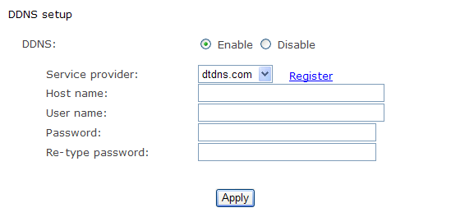
[DDNS] Enable or disable DDNS connection.
How to add DDNS
1. Enable the Dynamic DNS function.
2. Select your preferred DDNS service provider from the list then click Register.
3. Enter the Host Name details and password supplied by your DDNS service provider when you registered.
4. Click Apply to confirm your settings.

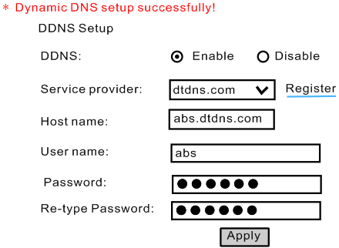

UPNP Setup

Warning: Using DDNS to view the camera should cancel the 3G function.
The camera supports UPnP which is enabled by default. This function requires a Windows XP/Vista operating system. It is a quick way to discover the camera on your network. Please make sure that the UPnP function is enabled on your PC.

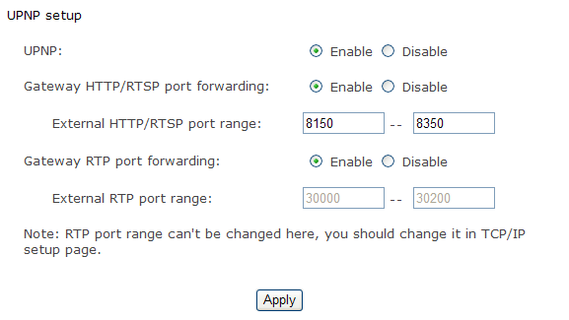

[UPnP] Enable or disable the UPnP function.

[Gateway HTTP/RTSP port forwarding] Enable or disable this function.

[External HTTP/RTSP port range] Using this port, automatically adds a port forwarding rule to a router via UPnP protocol. Please note that not all routers support this function. Refer to your router manual for further details.

If set port range is 8150~8350, camera will ask router to add a port forwarding rule automatically. In this rule, the internal port is camera default port 80, the external port is 8150, IP address is camera's IP. Use this setting, users can visit the camera from Internet through the router with this URL http://routeripaddress:8150.

If there are several cameras in Local Network, the first one which first be opened will use 8150 as external port, and second one will use 8151, third one use 8152, etc. Every camera will remember its port, it will preferentially use this port in next power on.

[Gateway RTP port forwarding] Enable this function, users can use mobile phone , RealPlayer or QuickTime Player to visit the camera from Internet through the router.

[External RTP port range] 30000—30200 default. (See TCP/IP setup)

Click Apply to confirm your setting.

Click System at the top right of Settings page to show the System information. See figure below. 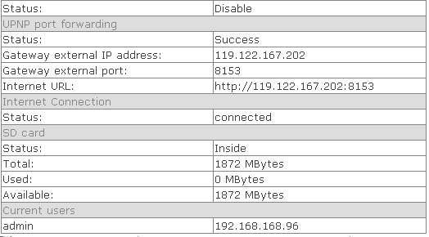

If DDNS setup successfully and go into effect, Internet URL will show DDNS host name instead.
See figure below for example.

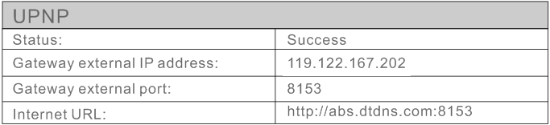

P2P Setup

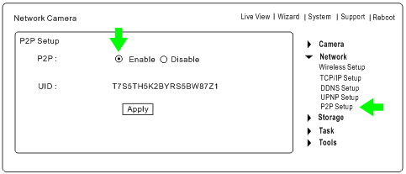
Click P2P Setup, then click Enable and apply to add P2P functions.
Now we can use P2P to view cameras on PC or iPhone, iPad and Android.
Only need to input UID and passward.
Take viewing on PC and iPhone for example.
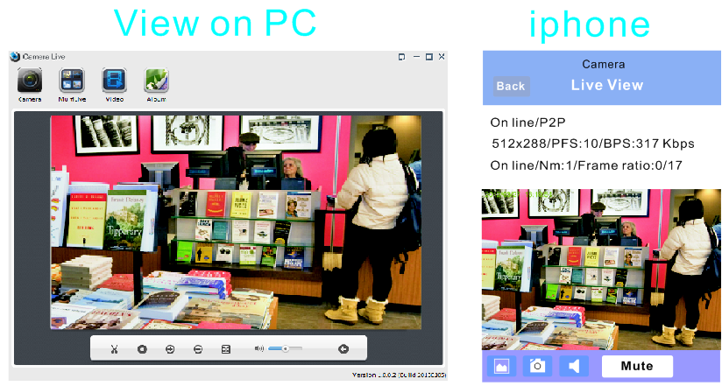
Storage

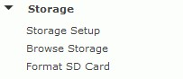

Storage Setup
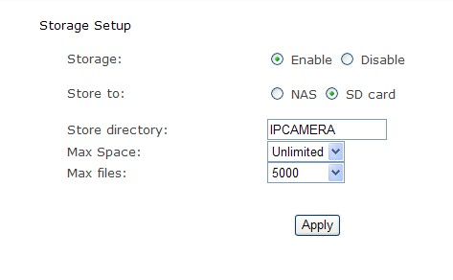
[Storage] Select Enable
[Store to] NAS or SD Card
[Store directory] The file that Videos will be saved to.
[Max Space] Unlimited (The capacity of all videos)
[Max files] The Max quantity of all the videos.

Click Apply to confirm your setting.

Store to NAS
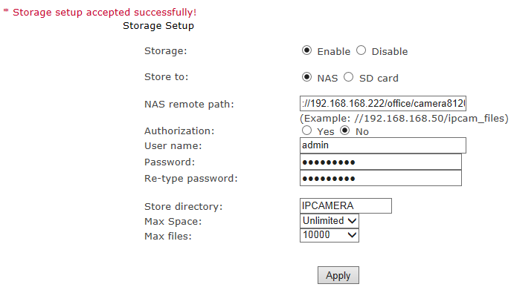

[Store to] Select NAS
[NAS remote path] IP address of the NAS. Example://192.168.168.50/ipcam_files
[Authorization] Select Yes
[User name] Input the NAS user name.
[Password] Input NAS password
[Re-type password] Re-type the NAS password.

Click Apply to confirm your setting.

Browse Storage
When click Browse Storage and you can browse, download, delete the snapshot and recording files in it.

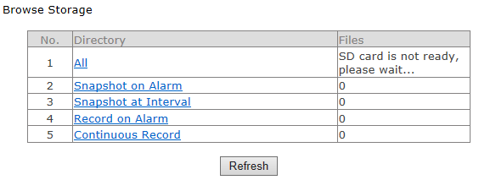

Format SD Card
To format SD card, all files will be losted after format.

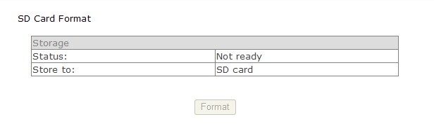

Task

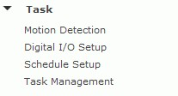

Motion Detection

Motion Detection can trigger an alarm that sends images or video feed via e-mail or FTP (File Transfer Protocol). You can set up to four different Motion Detection windows.

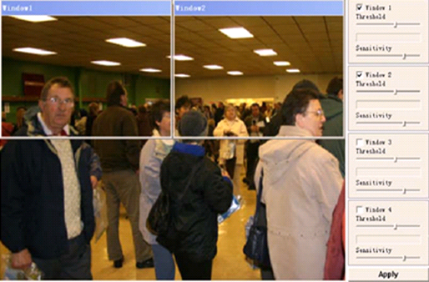

[Window] Check this box to enable the window.
[Threshold] Set the threshold bar to the amount of motion required to trigger the alarm.
[Sensitivity] Set the measurable difference between two sequential images that would indicate motion.

Click Apply to confirm your setting.

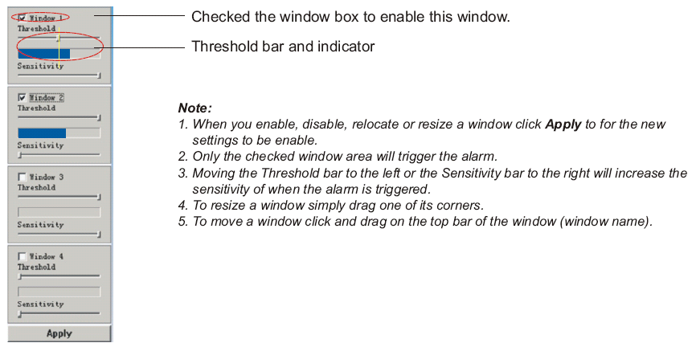

Digital I/O Setup
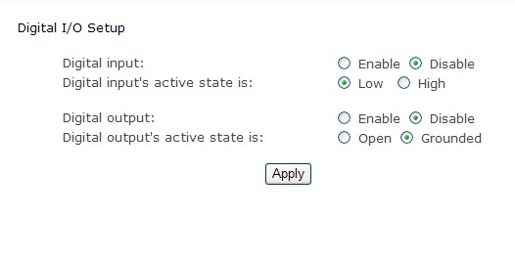
[Digital input] Select Enable or Disable.
[Digital input’s active state is] Select Low or High.

[Digital output] Enable or Disable.
[Digital output’s active state is] Open or Grounded.

Click Apply to confirm your setting.

Schedule Setup
Alarm Sending, Periodical Sending and Buffer Sending sends images via e-mail or FTP according to schedule setup.

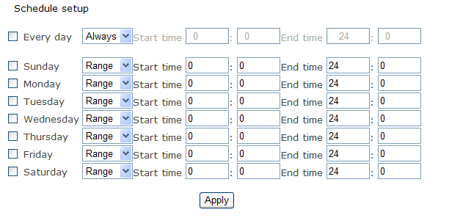
[Every day] Select every day or not.
[Sunday ~ Saturday] Select Sunday ~ Saturday or not.
[Always] Enable in any time.
[Range] Enable between start time and end time.
[Except] Enable except start time to end time.

Click Apply to confirm your setting.

Task Management
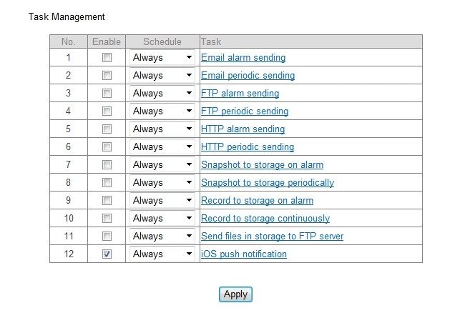

E-mail alarm sending
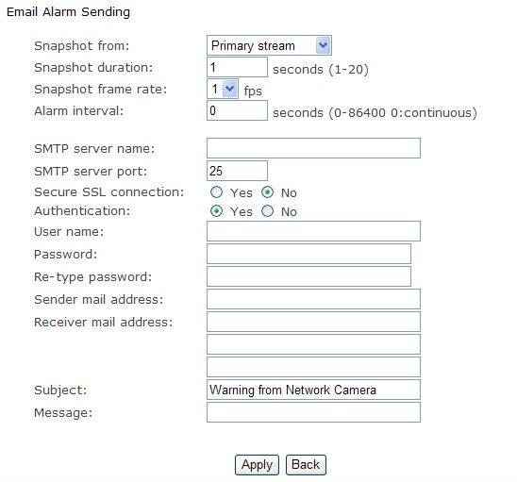

[Snapshot from] Select Primary stream
[Snapshot duration] Input the number of seconds
[Snapshot frame rate] Select the frame
[Alarm interval] Input the interval time
[SMTP server name] Input your E-mail’s SMTP server name.
[SMTP server port] 25, as default.
[Secure SSL connection] Select No. For Gmail, select Yes. It depends on the mail system.
[Authentication] Select Yes
[User name] Input your E-mail user name.
[Password] Input your E-mail password.
[Sender mail address] Input the sender mail address
[Receiver mail address] Input the receiver mail address.

Click Apply to confirm your setting.

E-mail Period Sending
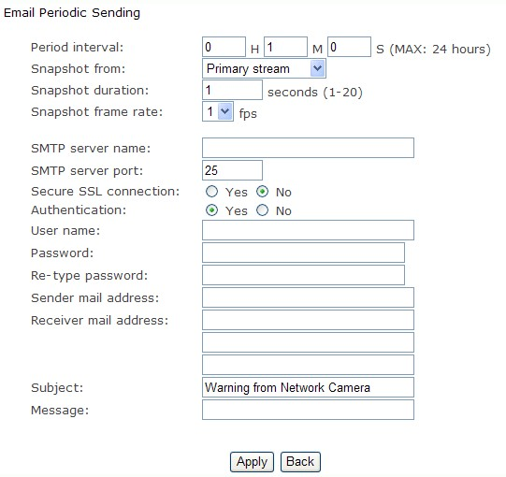

[Periodic interval] Input the interval time.

The rest setting is the same as E-mail Alarm Sending.
Click Apply to confirm your setting.

FTP alarm sending
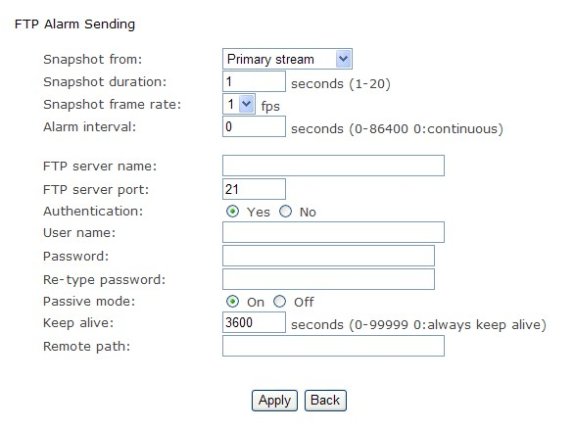

[Snapshot from] Primary stream.
[Snapshot duration] Input the duration time.
[Snapshot frame rate] Select the number of frame per second.
I Alarm interval] Type the interval time.
[FTP server name] Input the FTP server name.
[FTP server port] As default 21.
[Authentication] Select Yes.
[User name] Type your FTP user name.
[Password] Type your FTP password.
[Re-type password] Re-type FTP password.
[Passive mode] Select on or off.
[Keep alive] Input the time.
[Remote path] Input the file directory.

Click Apply to confirm your setting.

FTP periodic sending
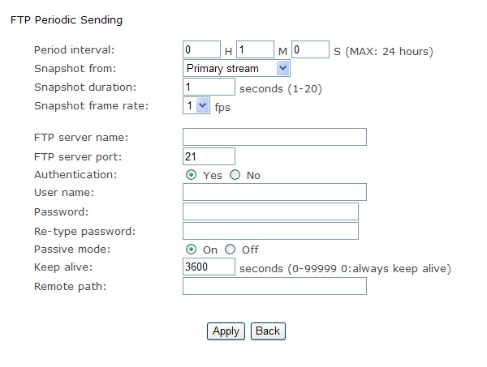

[Periodic interval] Input the interval time.

The rest setting is the same as FTP Alarm Sending.
Click Apply to confirm your setting.

HTTP alarm sending

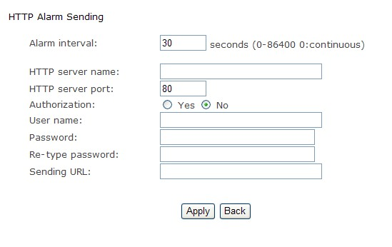

[Alarm interval] Input the FTP server name.
[HTTP server name] Input the HTTP server name.
[HTTP server port] As default 80.
[Authentication] Select Yes.
I User name] Type your HTTP user name.
[Password] Type your HTTP password.
[Re-type password] Re-type your HTTP password.
[Sending URL] Input Input the URL, the camera will give an alarm to it.

Click Apply to confirm your setting.

HTTP periodic sending

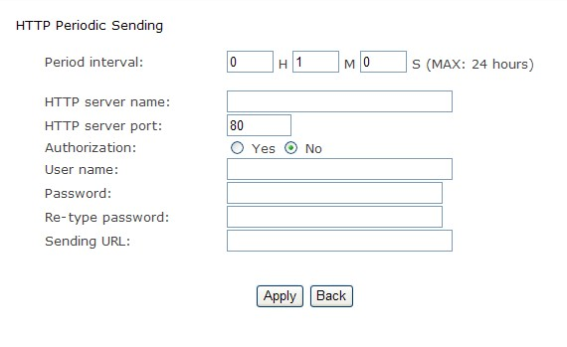

[Period interval] Input the interval time.

The rest setting is the same as HTTP Alarm Sending.

Click Apply to confirm your setting.

Snapshot to storage on alarm
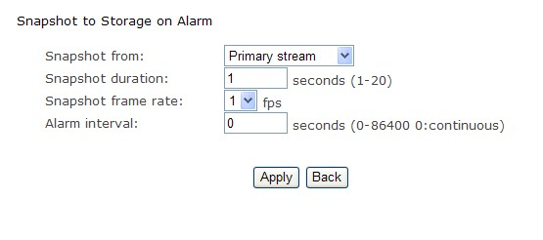
[Snapshot to storage on alarm] Select Primary stream.
[Snapshot duration] Select the time.
[Snapshot frame rate] Select the frame.
IAlarm interval] Input the interval time.

Click Apply to confirm your setting.

Snapshot to storage periodically

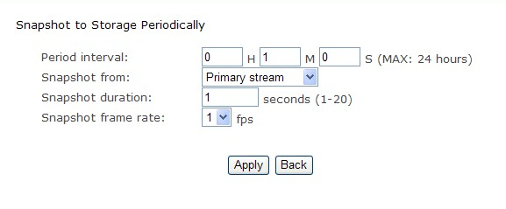

[Period interval] Input the interval time.

The rest setting is the same as Snapshot to storage on alarm.

Click Apply to confirm your setting.

Record to storage on alarm
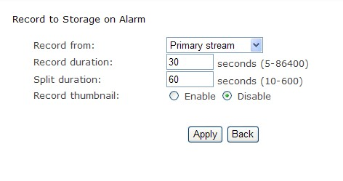
[Record from] Primary stream
[Record duration] Input the duration time.
[Split duration] Input the split duration time.( The videos will be split.)
[Record thumbnail] Select Enable or Disable.

Click Apply to confirm your setting.

Record to storage continuously
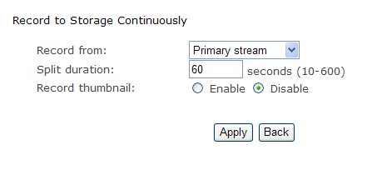
[Record from] Select Primary stream.
[Split duration] Input the split duration time.( The videos will be split.)
[Record thumbnail] Select Enable or Disable.

Click Apply to confirm your setting.

Send files in storage to FTP server
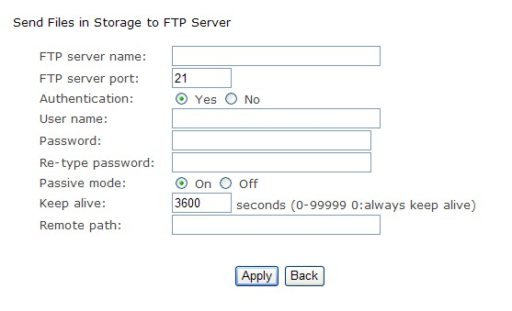
[FTP server name] Input the FTP server name.
[FTP server port] As default 21.
[Authentication] Select Yes.
IUser name] Type the FTP user name.
[Password] Input the FTP password.
IRe-type password] Re-input the FTP password.
[Passive mode] Select on or off.
[Keep alive] Input the time.
[Remote path] Input the file directory.

Click Apply to confirm your setting.

IOS push notification
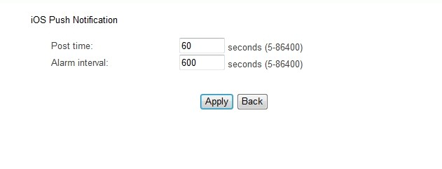
[Post time] input the post time
[Alarm interval] input the alarm interval time

Click Apply to confirm your sett

Tools
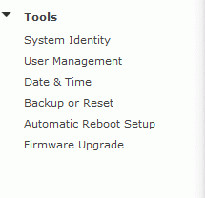

System Identity
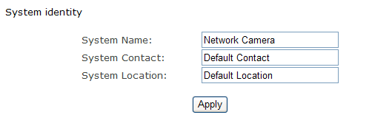
[System Name] Type a name to easily identify the camera.
[System Contact] Type the contact name of the administrator of the camera.
[System Location] Type the location of the camera.

TIP: The information you fill in can be displayed on the camera. It can help to distinguish different Network Cameras in the network. See figure below.

User Management
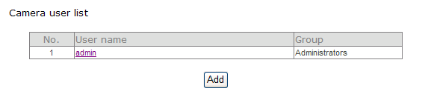

[Add] Up to 64 users (including the admin) can created
Note:
1. A maximum of 16 users are allowed to access the camera simultaneously.
2. As the number of simultaneously users increase, the overall performance will decrease. This is dependant on the Network bandwidth.

Adding users
1. Click Add on the Camera User List page.
2. Enter the User name, Password and re-confirm the password then click Add.

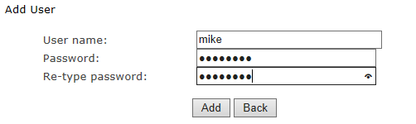

To edit a user’s password, click on the user name then enter the new password for that user twice and click Save. To delete a user, click on the user name then click Delete.

Date & Time
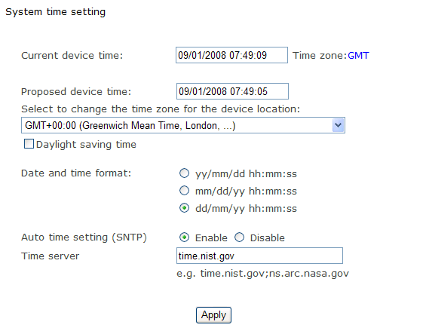
[Current device time] Internal time for camera.
[Proposed device time] PC system time. On clicking Apply the internal time of the camera will be changed to this time.
[Select to change the time zone for the device location] choose proper time zone.
[Daylight saving time]Daylight Saving Time (or summertime as it is called in many countries) is a way of getting more light out of the day by advancing clocks by one hour during the summer.
[Date and time format] Select date and time format.
[Auto time setting(SNTP)] Enable or disable this function.
[Time server] Type one SNTP server name in the box.

Click Apply to confirm your settings.

Note:
1. If the SNTP server is not found the camera’s time will be synchronized with the PC time.
2. The camera has a built-in RTC(Real-time Clock) that keeps track of the time even when power is
disconnected.

Backup or Reset
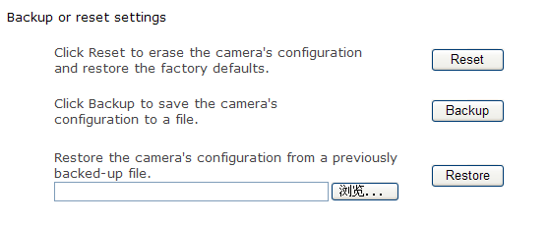

[Reset] Click Reset to initialize the camera to default factory setting. All users and settings will be
lost, requiring you to reconfigure the camera.

[Backup] Click Backup to backup the current configuration of the camera for future reference.

[Browse...] Click Browse... to search for a backup configuration you wish to upload to the camera, then
click Restore.
Note:
Do not turn off the power during the Reset, Backup or Restore functions since this might corrupt the camera’s firmware
Tip:
The camera can also be reset to the default settings by pressing the reset switch on the side of the camera.

Automatic reboot setup
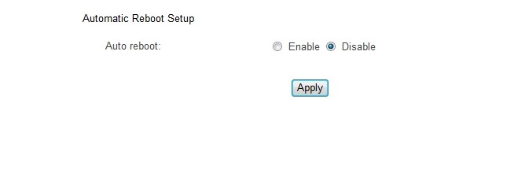
[Auto reboot]select enable or disable

Click Apply to confirm your setting

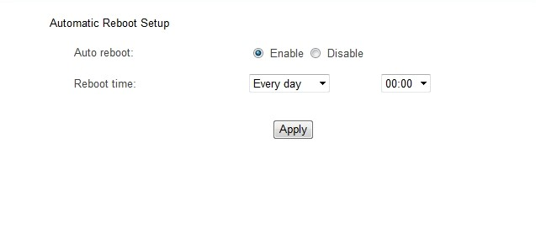
[Auto reboot] select enable
[Reboot time] select day and time
Click Apply to confirm your setting

Note: Whether you select the day to auto reboot, the camera will auto reboot every day at the time you set.

Firmware Upgrade
From time to time a new firmware may be released. In order to upgrade your camera’s firmware you first need to download this firmware from Network Camera Technical Support Site.

1. Click Continue.

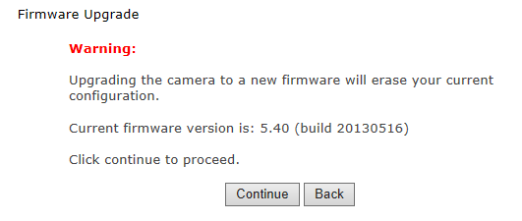
2. Click Browse... to search for the newest Firmware you downloaded, and then click Upgrade.
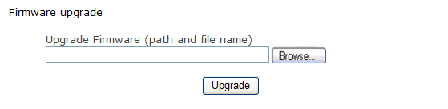
3. Click Reboot when the upgrade terminates.

IMPORTANT:
* Do not unplug or power off the camera while the upgrade is in progress.

SPEEDREAD YOUR NETWORK CAMERA

Wizard
In order to facilitate the setup of the camera there is a Wizard that helps non technical users setup the camera easily. Click on Wizard at the top of the window to launch the wizard.

The Quick setup interface will pop up. Follow the simple instructions on the screen and enter the required details, clicking next to proceed to the Next page.

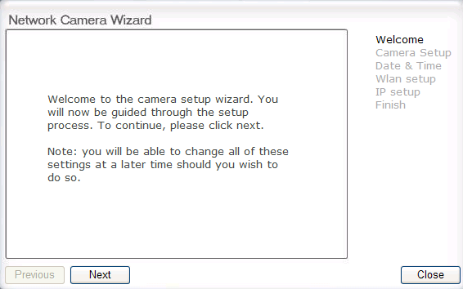

System
Click System to see over system information about your camera. The data of the software activity of the camera and recorded in this. It includes data that are useful when a problem occurs.

Support
Click Support to see the support information

Reboot

Click Reboot to restart the camera. Rebooting the camera will retain all the settings and configurations.

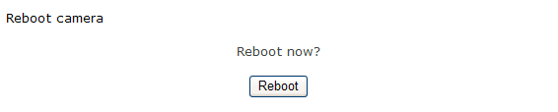

ADVANCED SETTINGS

Port Forwarding

The UPnP Setup of camera show a method of Port Forwarding（see page 31 for details），but some routers maybe can’t support UPnP Port Forwarding, therefore, users need to configure Port Forwarding manually.

Firewall security features built into the router may prevent users from accessing the camera over the Internet. The router connects to the Internet over a series of “ports”. The default ports used by the camera are usually blocked from access over the Internet, therefore, these ports need to be made accessible. This is achieved using the Port Forwarding function on the router. The ports used by the camera must be opened through the router for remote access to your camera. Check your router’s user manual for specific instructions on how to open and route ports on you router.

Important: Some ISPs block access to port 80 and other commonly used Internet ports. Check with your ISP in order to open the appropriate ports. If your ISP does not pass traffic on port 80, you will need to change the camera’s default port number from 80 to a different number such as 9000.

Viewing Your Camera

To access the camera from a computer on your local network, simply enter the IP Address of the Camera followed by a colon and the camera’s port number. It is not necessary to enter the colon and port number if you are using the camera’s default port 80.

To access the camera from the internet, type the external IP Address of the router, followed by a colon, and the port number of your camera (e.g., Http://210.118.166.68:9000).

Proxy Server Setting
A proxy server may prevent you from connecting to the camera in some corporate environments. The web browser can set up the IP address communication without using a proxy server. Consult your ISP or network administrator for further details.

Note: A proxy server is generally used to maintain security on a network when connected to the internet. Theproxy server may cause lack of image quality and delays in refresh intervals. Consult your ISP or network administrator for further details.

1. Start Internet Explorer.
2. Select [Tools] –> [Internet Options...] –> [Connections] tab and click [LAN Settings].
Verify that the Use a proxy server check box is not checked. When checked, click [Advanced...].

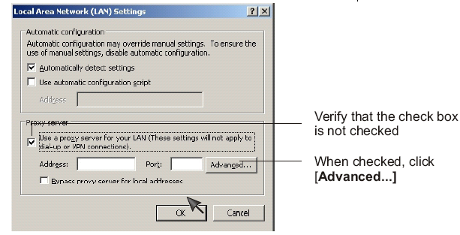

When not checked, click [Cancel]. Your proxy server settings should not cause any problems.

3. Enter the IP address of your camera into the Do not use proxy server for addresses beginning with data field.

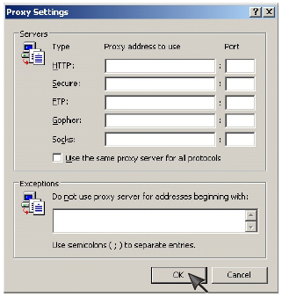

4. Click [OK] on all of the opened windows.

Reset the camera

There are two ways to reset the camera back to its factory defaults:

1. Press the Reset button on the side of the camera through the pin hole.

2. Through the camera setup under the heading Backup or Reset.

DEFAULT SETTINGS
Camera
Camera Setup
Privacy mode | Off
Moonlight mode | Off
Image rotation | Off
Light frequency | 60Hz
Microphone | Enable
Mic Volume | 10
Audio Bit Rate | ACC
Stream Setup
Primary stream |  | Enable
Image size |  | 640 x 480
Frame rate |  | 30fps
H.264/MPEG4 bit rate |  | 2048kbps
MJPEG quality |  | 50
Snapshot quality |  | 90
Audio |  | Enable
RTSP authentication |  | Enable
Secondary stream |  | Disable
Image size |  | 320 x 240
Frame rate |  | 30fps
H.264/MPEG4 bit rate |  | 512kbps
MJPEG quality |  | 50
Snapshot quality |  | 90
Audio |  | Enable
RTSP authentication |  | Enable
Mobile stream |  | Enable
Image size |  | 176 x 144
Frame rate |  | 10fps
H.264/MPEG4 bit rate |  | 64kbps
Snapshot quality |  | 70
Audio |  | Disable
RTSP authentication |  | Enable
OSD Setup
OSD | Disable
Transparent | Enable
Display | Display date and time
Night Vision Setup
Infrared LED control | Auto
Black and white mode | Auto

Network

TCP/IP Setup
IP address | 192.168.168.100
Subnet Mask | 255.255.255.0
Default Gateway | Blank
Primary DNS IP Address | Blank
Secondary DNS IP Address | Blank
HTTP Port | 80
RTSP port | 554
RTP port range | 30000—30200
Authentication method | Basic
DDNS Setup
DNS | Disable
Service provider | dtdns.com
Host name | Blank
User name | Blank
Password | Blank
Re-type password | Blank
UPnP Setup
UPnP | Enable
Gateway HTTP/RTSP port forwarding | Enable
External HTTP/RTSP port range | 8150--8350
Gateway RTP port forwarding | Enable
External RTP port range | 30000--30200

Alarm

Motion Detection
Window 1 | Blank
Window 2 | Blank
Window 3 | Blank
Window 4 | Blank
Schedule Setup
Every day |  | Always
Alarm Sending
Alarm mode |  | Arm
FTP alarm sending |  | Disable
Trigger time |  | 5
Trigger FPS |  | 1
FTP server ID |  | 1
Remote path |  | Blank
Snapshot from |  | Primary stream
Image file name |  | M
Suffix of file name |  | Date time
Effective period |  | Always
e-Mail alarm sending |  | Disable
Trigger time |  | 1
Trigger FPS |  | 1
e-Mail server ID |  | 1
File attachment |  | On
Snapshot from |  | Primary stream
Image file name |  | M
Suffix of file name |  | Date time
Effective period |  | Always
HTTP event alarm sending |  | Disable
HTTP server ID |  | 1
Sending URL |  | Blank
Use MAC address as URL suffix |  | Disable
Effective period |  | Always
Periodical Sending
FTP periodical sending |  | Disable
Interval time |  | 0H 1M 0S 0mS
FTP server ID |  | 1
Remote path |  | Blank
Snapshot from |  | Primary stream
Image file name |  | P
Suffix of file name |  | Date time
Effective period |  | Always
e-Mail periodical sending |  | Disable
Interval time |  | 0H 1M 0S 0mS
e-Mail server ID |  | 1
File attachment |  | On
Snapshot from |  | Primary stream
Image file name |  | P
Suffix of file name |  | Date time
Effective period |  | Always
HTTP periodical sending |  | Disable
Interval time |  | 0H 1M 0S 0mS
HTTP server ID |  | 1
Sending URL |  | Blank
Use MAC address as URL suffix |  | Disable
Effective period |  | Always
Buffer Sending
Image buffer |  | Disable
Buffer time |  | 20
Buffer FPS |  | 4
Snapshot from |  | Primary stream
Image file name |  | Blank
Suffix of file name |  | Date time
FTP buffer sending |  | Disable
FTP server ID |  | 1
Remote path |  | Blank
Estimate sending time |  | 100
Effective period |  | Always

Alarm Server
FTP Server
FTP server ID | 1
FTP Server Name | Blank
FTP Server Port | 21
Anonymous | No
User Name | Blank
Password | Blank
Re-type Password | Blank
Passive Mode | On
Keep alive | 3600
e-Mail Server
e-Mail server ID | 1
SMTP Server Name | Blank
SMTP Server Port | 25
Secure SSL connection | No
Authentication | Yes
User Name | Blank
Password | Blank
Re-type Password | Blank
Sender E-Mail Address | Blank
Receiver E-Mail Address | Blank
Receiver E-Mail Address | Blank
Receiver E-Mail Address | Blank
Subject | Warning from Network Camera
Message | Blank
HTTP Server
HTTP server ID | 1
HTTP server name | Blank
HTTP server port | 80
Authorization | No
User Name | Blank
Password | Blank
Re-type Password | Blank

Tools
System Identity
System Name | Network Camera
System Contact | Default Contact
System Location | Default Location
User Management
1 | Admin/Administrators
Date & Time
Current Device Time | Current PC Time
Time Zone | GMT
Proposed Device Time | Current PC Time
Daylight saving time | Disable
Date and time format | dd/mm/yy hh:mm:ss
Auto Time Setting (SNTP) | Enable
Time Server | Time.nist.gov
Misc Setup
LED Control | On
Show FPS in Active Control | Off
VGA SPECIFICATIONS (Optional)

Camera
Image device | 1/4" CMOS
Pixels | 310,000
White Balance | Auto
Exposure mode | Auto
Gain | Auto
Viewing angle | Horizontal:50°, Vertical:40°
Focal length | F=4.3mm
Aperture | F2.0
Min.illumination | 1.0 Lux(0 Lux in nightvision mode )
Infrared LED | 12
Night Vision Distance | 15m
IR cut filter | YES
Outdoor IP66-rated | YES
Audio output(2 way audio) | YES
Digital I/O | YES
SD card support | 16Mb-128Gb
Network
Support | P2P
Image compression | H.264、MPEG-4、MJPEG
Image resolution | 640x480(VGA), 320x240(QVGA), 160x120(QQVGA)
Max. frame rate | 30fps @640x480
Audio compression | AAC
Built-in microphone | Electret Condenser Microphone
Simultaneous viewers | 16
Authentication | ID/Password, Administrator/General User (Up to 64)
Network protocols | TCP、UDP、IP、ARP、ICMP、DHCP、DNS、HTTP、FTP、SMTP、NTP, UPnP、DDNS
Stream type | HTTP, RTSP/RTP/RTCP, 3GPP
Network connection | Ethernet (10BASE-T/100BASE-TX)
3G
3G | WCDMA
Frequency | 824~960/1710~2170
Transmission speed | 150Mbps/54Mbps/11Mbps/5.5Mbps/2Mbps/1Mbps(Auto Switch)
Security | WEP (64/128 bit)、 WPA-PSK(AES/TKIP)、 WPA2-PSK(AES/TKIP)
General
Power requirements | DC 12V
Power consumption | 3.75W
Operating temperature | -20 to +60 °C (-4 to +140 °F)
Storage temperature | -20 to +60 °C (-4 to +140 °F)
Operating humidity | 20～80%RH(Non-condensing)
Storage humidity | 20～95%RH(Non-condensing)
Dimensions(W x D x H mm) | φ70mmX190mm
Weight(Main Body) | 750g
PC system requirements
Operating system | Windows 2000、XP、VISTA、Windows 7、Windows 8、MAC OS、Linux、Android、iphone OS
Processor | Intel Pentium III, 1GHz or Higher
Memory | 256MB RAM Minimum
Web browser | Microsoft Internet Explorer Version 5.5 or Later Safari、Mozilla Firefox、Google Chrome and most other browsers

720P SPECIFICATIONS (Optional)
Camera
Image device | 1/4" CMOS
Pixels | 921,600
White Balance | Auto
Exposure mode | Auto
Gain | Auto
Viewing angle | Horizontal:55°, Vertical:30°
Focal length | F=4.3mm
Aperture | F2.0
Min.illumination | 1.0 Lux(0 Lux in nightvision mode )
Infrared LED | 12
Night Vision Distance | 15m
IR cut filter | YES
Outdoor IP66-rated | YES
Audio output(2 way audio) | YES
Digital I/O | YES
SD card support | 16Mb-128Gb
Network
Support | P2P
Image compression | H.264、MPEG-4、MJPEG
Image resolution | 1280x720(720P),640x480(VGA), 320x240(QVGA), 160x120(QQVGA)
Max. frame rate | 30fps @1280x720
Audio compression | AAC
Built-in microphone | Electret Condenser Microphone
Simultaneous viewers | 16
Authentication | ID/Password, Administrator/General User (Up to 64)
Network protocols | TCP、UDP、IP、ARP、ICMP、DHCP、DNS、HTTP、FTP、SMTP、NTP、UPnP、DDNS
Stream type | HTTP, RTSP/RTP/RTCP, 3GPP
Network connection | Ethernet (10BASE-T/100BASE-TX)
3G
3G | WCDMA
Frequency | 824~960/1710~2170
Transmission speed | 150Mbps/54Mbps/11Mbps/5.5Mbps/2Mbps/1Mbps(Auto Switch)
Security | WEP (64/128 bit)、 WPA-PSK(AES/TKIP)、 WPA2-PSK(AES/TKIP)
General
Power requirements | DC 12V
Power consumption | 3.75W
Operating temperature | -20 to +60 °C (-4 to +140 °F)
Storage temperature | -20 to +60 °C (-4 to +140 °F)
Operating humidity | 20～80%RH(Non-condensing)
Storage humidity | 20～95%RH(Non-condensing)
Dimensions(W x D x H mm) | φ70mmX190mm
Weight(Main Body) | 750g
PC system requirements
Operating system | Windows 2000、XP、VISTA、Windows 7、Windows 8、MAC OS、Linux、Android、iphone OS
Processor | Intel Pentium III, 1GHz or Higher
Memory | 256MB RAM Minimum
Web browser | Microsoft Internet Explorer Version 5.5 or Later Safari、Mozilla Firefox、Google Chrome and most other browsers

1080P SPECIFICATIONS (Optional)
Camera
Image device | 1/2.7" CMOS
Pixels | 2,073,600
White Balance | Auto
Exposure mode | Auto
Gain | Auto
Viewing angle | Horizontal:90°, Vertical:50°
Focal length | F=3.8mm
Aperture | F2.0
Min.illumination | 1.0 Lux(0 Lux in nightvision mode )
Infrared LED | 12
Night Vision Distance | 15m
IR cut filter | YES
Outdoor IP66-rated | YES
Audio output(2 way audio) | YES
Digital I/O | YES
SD card support | 16Mb-128Gb
Network
Support | P2P
Image compression | H.264、MPEG-4、MJPEG
Image resolution | 1920x1080(1080P),1280x720(720P),640x480(VGA), 320x240(QVGA), 160x120(QQVGA)
Max. frame rate | 15fps @1920x1080
Audio compression | AAC
Built-in microphone | Electret Condenser Microphone
Simultaneous viewers | 16
Authentication | ID/Password, Administrator/General User (Up to 64)
Network protocols | TCP、UDP、IP、ARP、ICMP、DHCP、DNS、HTTP、FTP、SMTP、NTP、UPnP、DDNS
Stream type | HTTP, RTSP/RTP/RTCP, 3GPP
Network connection | Ethernet (10BASE-T/100BASE-TX)
3G
3G | WCDMA
Frequency | 824~960/1710~2170
Transmission speed | 150Mbps/54Mbps/11Mbps/5.5Mbps/2Mbps/1Mbps(Auto Switch)
Security | WEP (64/128 bit)、 WPA-PSK(AES/TKIP)、 WPA2-PSK(AES/TKIP)
General
Power requirements | DC 12V
Power consumption | 3.75W
Operating temperature | -20 to +60 °C (-4 to +140 °F)
Storage temperature | -20 to +60 °C (-4 to +140 °F)
Operating humidity | 20～80%RH(Non-condensing)
Storage humidity | 20～95%RH(Non-condensing)
Dimensions(W x D x H mm) | φ70mmX190mm
Weight(Main Body) | 750g
PC system requirements
Operating system | Windows 2000、XP、VISTA、Windows 7、Windows 8、MAC OS、Linux、Android、iphone OS
Processor | Intel Pentium III, 1GHz or Higher
Memory | 256MB RAM Minimum
Web browser | Microsoft Internet Explorer Version 5.5 or Later Safari、Mozilla Firefox、Google Chrome and most other browsers

Frequently Asked Questions
If the Network Camera is not working properly, these suggestions might help you identify the problem. If the problem persists check the support pages on Network Camera Technical Support Site.
Problem | Cause and Remedy
Forget the IP address of network camera. | 1. Use Camera Setup.  2. Use UPNP (for XP/Vista OS)  3. Reset your Network to default IP address
Forget the password to access the setting interface. | Initialize the network camera by pressing the RESET button. Note that all configuration settings will be lost.
Wireless communication does not work. | 1. Signal strength is weak. Relocate the camera or remove the obstacle around it.  2. Make sure the SSID and Encryption settings are identical.  3. Check for any interference from other equipment.
The picture viewing interface does not appear. | 1. Check that your internet explorer settings allow you to download and install ActiveX controls.  2. Maximum 16 users are allowed to access the camera simultaneously through network.  3. Network traffic may prevent the viewing interface from appearing quickly. Wait for a while.
How many users can view the same camera at the same time? | 16
How many cameras can we view in one window? | 36
How many cameras can we view in the browser? | Countless. Depends on the network speed.
When the camera is viewing in the browser, can we use the same PC and view the same camera in another browser window? | No, the camera knows it’s already open.
The color of the picture is strange. | Confirm the color setting of PC is 16 bits or more.
The unreadable characters are displayed. | Set the Encoding or the Character Set of the selected language on the web browser.
Can the camera support viewing in Mac, Linux OS? | Yes, In Mac, Linux OS, we support viewing in the website, using DDNS.  The PC softwares only support all Windows OS so far.
Why in Mac OS, the videos delay 2 seconds? | Because the Mac OS only support QuickTime player in browsers. So it delays 2 seconds. Other OS will not delay.
Why we see strips in the videos? | Because of the electricity. Some country like USA is 60Hz, yet Europe is 50Hz. For example：In USA, the camera should choose 60Hz, otherwise we will see strips in the videos. The following picture is the steps.
How to set the video quality in iPhone, iPad， Android devices. | Please see the below steps.

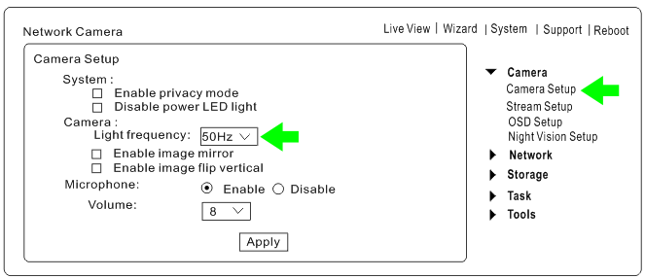

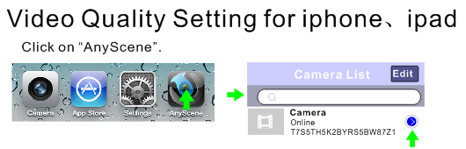
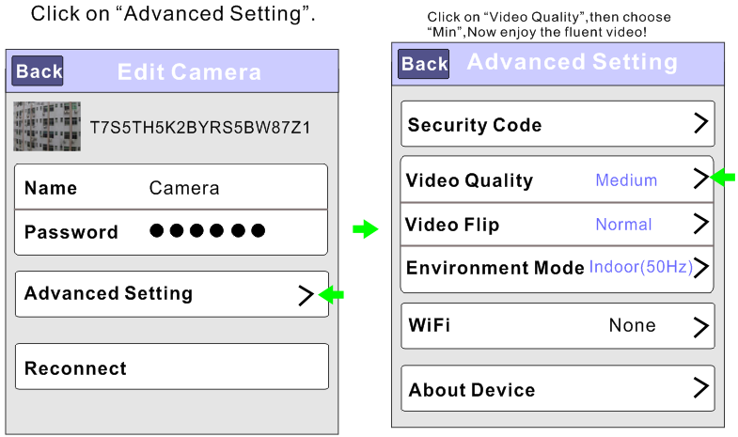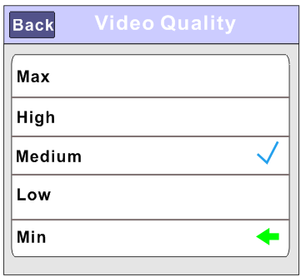

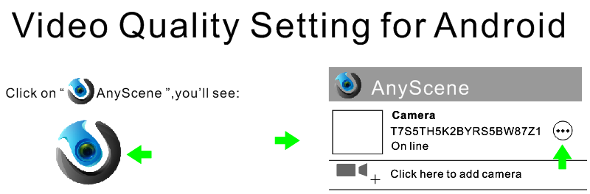
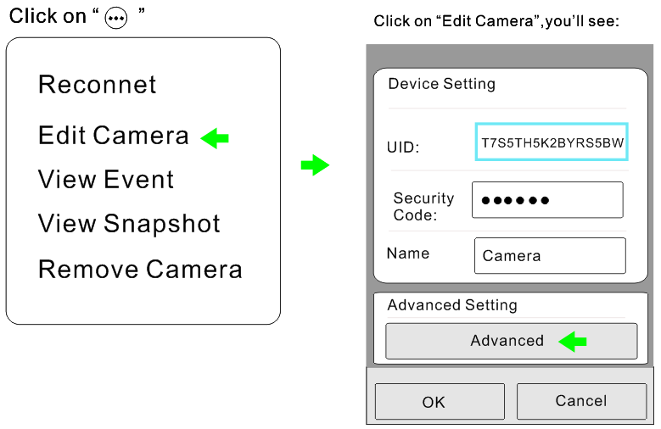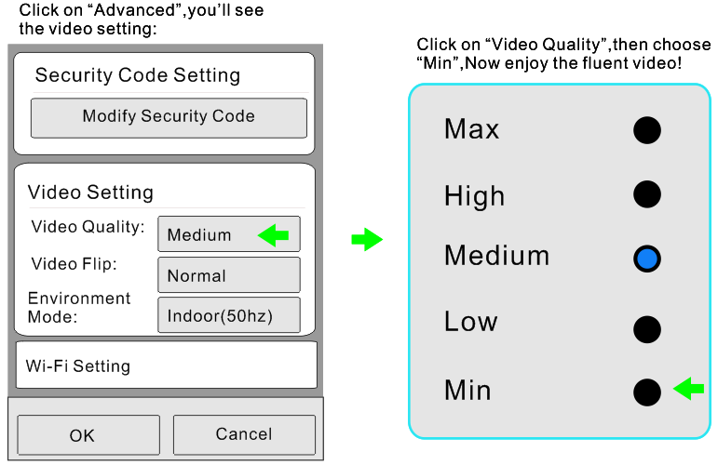
GLOSSARY OF TERMS
1. Network Camera: A stand-alone device which allows users to view live, full motion video from anywhere on a computer network, even over the Internet, using a standard web browser.

2. JPEG: A standard image format, used widely for photographs, also known as JPG.

3. IEEE 802.11b/g/n: The specifications developed by the IEEE for wireless network technology. It provides 11 Mbps transmission in the 2.4GHz band usage.

4. WEP: Wireless Equivalent Privacy. A security protocol for wireless network defined in the IEEE 802.11b/g/n standard. WEP aims to provide security by encrypting data over radio waves so that it is protected as it is transmitted from one end point to another.

5. Adhoc Mode: A wireless network system in which devices communicate directly with each other, without the use of a wireless router.

6. Infrastructure Mode: One of the wireless network system in which devices communicate with each other by first going through the wireless router.

7. IP Address: The unique 32 bit number assigned to each computer connected to the Internet. IP numbers are used by the TCP/IP protocol to route packets of data to their destinations.

8. TCP/IP: The collection of "protocols" underlying the functioning of the Internet. Each computer connected to the Internet is identified by a unique IP Address.

9. SMTP: Simple Mail Transfer Protocol.

10. FTP: File Transfer Protocol. Network cameras equipped with an embedded operating system, such as Linux, can use FTP to send images to a website.

11. DHCP: Dynamic Host Configuration Protocol is a set of rules used by communications devices such as a computer, router or network adapter to allow the device to request and obtain an IP address from a server which has a list of addresses available for assignment.

12 UPnP: Universal Plug and Play is an architecture for pervasive peer-to-peer network connectivity of intelligent appliances and wireless devices.

13. DDNS: DDNS is a method of keeping a domain name linked to a dynamic IP address with your Network Camera. You can set up your DDNS service and the device will automatically update your DDNS server each time it alter a different IP address.

14. Time server: A time server consists of a computer networking device that reads the actual time from a reference clock and distributes this information to its clients using a computer network.

15. WPA: Wi-Fi Protected Access (WPA and WPA2) is a class of systems to secure wireless (Wi-Fi) computer networks. WPA implements the majority of the IEEE 802.11i standard, and was intended as an intermediate measure to take the place of WEP while 802.11i was prepared.

